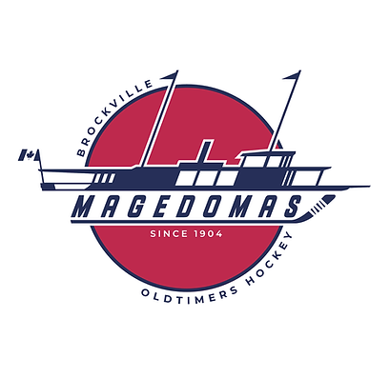

Dear Sponsor,

This year, I am proudly participating in the inaugural Brockville Magedoma’s Old Timer Hockey Tournament which will run from March 22nd through the 23rd at the Brockville Memorial Center.

The tournament unites friends and family from Brockville and the Surrounding area, as we celebrate our love of hockey as well as raising funds for the Brockville General Hospital in partnership with the Brockville District Hospital Foundation’s, Your Hospital, Your Health Fundraising Initiative.

With this in mind, we are reaching out to friends and businesses in our community that might like to support this initiative by way of a donation.

If you or your company already support the Brockville Hospital, or would like to do so, please consider making your donation through sponsorship of our tournament. Your donation will remain in your (or your company’s) name, is tax deductible, and will count toward our tournament’s fundraising goal.

More importantly, your donation will allow our world-class hospital to continue to provide world class health care to the residents of this great area.

Thank you for your consideration, and we look forward to a great experience for everyone this year.

Sincerely,

